Complete the following problems from Chapter 4:
- P4-5
- P4-6
- P4-9
- P4-15
- P4-18
Follow these instructions for completing and submitting your assignment:
- Please do all work in Excel. Do not submit Word files or *.pdf files.
- Submit a single spreadsheet file for this assignment. Do not submit multiple files.
- Place each problem on a separate spreadsheet tab.
- Label all inputs and outputs and highlight your final answer.
- Follow the directions in “Guidelines for Developing Spreadsheets.”

Guidelines for Developing Spreadsheets

It is important to develop spreadsheets that are clear, well-organized, and easy to read. Here are some tips that you will need to assist with your assignments.

- Your spreadsheet should be organized into three basic parts. Clearly label each part.
  - A title, labeling what your spreadsheet does. The title for your spreadsheets in this course can be the problem number that you are assigned. Place this in the upper left corner, in cell A1.
  - Inputs, which are given or assumed.
  - Results (Outputs) which the spreadsheet calculates.
- Provide specific labels for all inputs and outputs. Label both the variable names and the notation for the variables. Where a formula is involved, it is a good idea (but not necessary) to enter the formula to the right of the cell containing the results. I display these formulas in italics, so that they are not confused with the variable labels.
- Highlight the cell containing the final answer, using EXCEL’s yellow highlighter, which can be found on the top menu bar.
- If your spreadsheet uses a long formula, you might find it advisable to break the formula into component parts. This serves to minimize the typos that can occur when entering long formulas, as well as makes locating errors in the results easier to find. Nested parentheses are a particular problem in long formulas, and breaking up the calculations into component parts minimizes the need for nested parentheses also. In the example below, the calculations are broken into two steps; (1) the percentage changes in price and quantity demanded, and (2) the final elasticity calculation using these intermediate results.
- Don’t forget to place each homework problem on a separate spreadsheet tab. Label these tabs with the problem number for easy identification.

A sample spreadsheet reflecting these points is below.

Calculating Price Elasticity of Demand
Inputs:
Original Price (P1) | $10.00
New Price (P2) | $12.00
Original Quantity Sold (Q1) | 950
New Quantity Sold (Q2) | 900
Results:
% change in price (decimal form) | 0.2000 | =(p2-p1)/p1
% change in quantity demanded (decimal form) | -0.05263 | =(q2-q1)/q1
price elasticity of demand | -0.26316

P4–5
Classifying inflows and outflows of cash Classify each of the following items as an
inflow (I) or an outflow (O) of cash, or as neither (N).

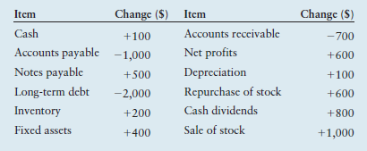

P4–6
Finding operating and free cash flows Consider the following balance sheets and
selected data from the income statement of Keith Corporation.

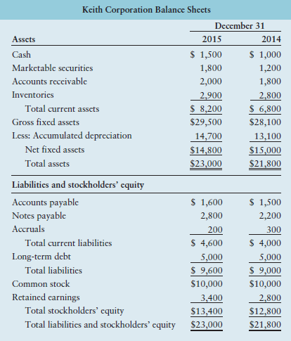

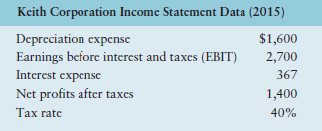

a. Calculate the firm’s net operating profit after taxes (NOPAT) for the year ended
December 31, 2015, using Equation 4.1. NOPAT = EBIT * (1 - T)

b. Calculate the firm’s operating cash flow (OCF) for the year ended December 31,
2015, using Equation 4.3. OCF = 3EBIT * (1 - T) 4 + Depreciation

c. Calculate the firm’s free cash flow (FCF) for the year ended December 31, 2015,
using Equation 4.4. FCF = OCF - Net fixed asset investment (NFAI) - Net current asset investment (NCAI)

d. Interpret, compare, and contrast your cash flow estimates in parts b and c.

P4–9
Cash budget: Basic Grenoble Enterprises had sales of $50,000 in March and
$60,000 in April. Forecast sales for May, June, and July are $70,000, $80,000, and
$100,000, respectively. The firm has a cash balance of $5,000 on May 1 and wishes
to maintain a minimum cash balance of $5,000. Given the following data, prepare
and interpret a cash budget for the months of May, June, and July.

(1) The firm makes 20% of sales for cash, 60% are collected in the next month,
and the remaining 20% are collected in the second month following sale.
(2) The firm receives other income of $2,000 per month.
(3) The firm’s actual or expected purchases, all made for cash, are $50,000,
$70,000, and $80,000 for the months of May through July, respectively.
(4) Rent is $3,000 per month.
(5) Wages and salaries are 10% of the previous month’s sales.
(6) Cash dividends of $3,000 will be paid in June.
(7) Payment of principal and interest of $4,000 is due in June.
(8) A cash purchase of equipment costing $6,000 is scheduled in July.
(9) Taxes of $6,000 are due in June.

P4–15
Pro forma income statement. The marketing department of Metroline Manufacturing
estimates that its sales in 2016 will be $1.5 million. Interest expense is expected
to remain unchanged at $35,000, and the firm plans to pay $70,000 in cash dividends
during 2016. Metroline Manufacturing’s income statement for the year ended
December 31, 2015, and a breakdown of the firm’s cost of goods sold and operating
expenses into their fixed and variable components are given below.

a. Use the percent-of-sales method to prepare a pro forma income statement for the
year ended December 31, 2016.

b. Use fixed and variable cost data to develop a pro forma income statement for the
year ended December 31, 2016.

c. Compare and contrast the statements developed in parts a and b. Which statement
probably provides the better estimate of 2016 income? Explain why.

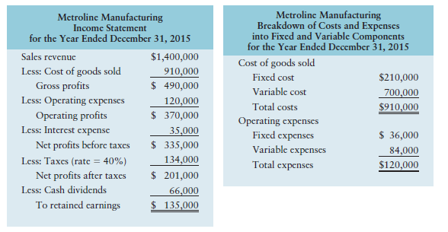

P4–18
Pro forma balance sheet. Peabody & Peabody has 2015 sales of $10 million. It
wishes to analyze expected performance and financing needs for 2017, which is
2 years ahead. Given the following information, respond to parts a and b.
(1) The percents of sales for items that vary directly with sales are as follows:
Accounts receivable, 12%
Inventory, 18%
Accounts payable, 14%
Net profit margin, 3%
(2) Marketable securities and other current liabilities are expected to remain
unchanged.
(3) A minimum cash balance of $480,000 is desired.
(4) A new machine costing $650,000 will be acquired in 2016, and equipment
costing $850,000 will be purchased in 2017. Total depreciation in 2016 is
forecast as $290,000, and in 2017 $390,000 of depreciation will be taken.
(5) Accruals are expected to rise to $500,000 by the end of 2017.
(6) No sale or retirement of long-term debt is expected.
(7) No sale or repurchase of common stock is expected.
(8) The dividend payout of 50% of net profits is expected to continue.
(9) Sales are expected to be $11 million in 2016 and $12 million in 2017.
(10) The December 31, 2015, balance sheet follows.

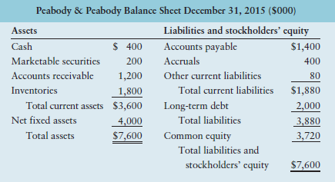

a. Prepare a pro forma balance sheet dated December 31, 2017.

b. Discuss the financing changes suggested by the statement prepared in part a.

